Manvinder Toor

February 22, 2018

N-Queens (n = 21)

1. Random-restart hill climbing

My Random Restart seemed to work 100% of the time. Although it runs hill climb multiple times and restarts when it reaches a local max or min. I had trouble figuring out how to set it up. I ran 100 iterations at n= 21and they all passed. Didn’t try to optimize this one. The cost I got was 15 million Nodes generated on Average. Average runtime is also around 500ms

2)Genetics Algorithm

I found that using a mutation rate of greater than 50% gave me faster results. I also found that 100% of the time I found a solution. Average number of generations was around 3000 to 4000. And average runtime was around 300ms. I had trouble with the fitness at first, I was not following the example in the book. I was doing currentFitness/maxFitness to get a normalized fitness score. That was throwing my program into weird cycles. I decided to follow the format of the book and also I just took the population /8 and made a gene pool and started mating those to make a new generation. To increase speed I played with population size, mutation rate, and the number of the old population I was using for mating. I found that higher mutation lead to faster speeds and 150 population size also gave me good speed.

Raw data in a.txt file

Genetics

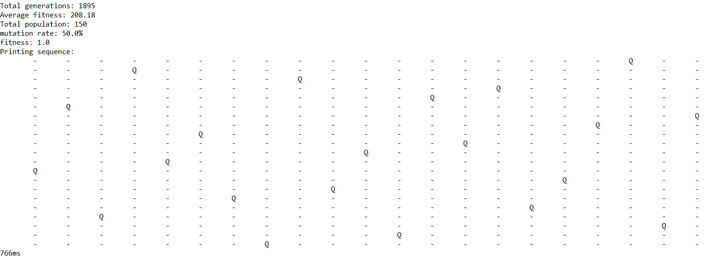

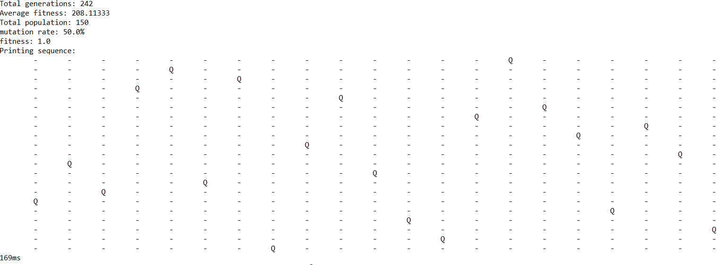

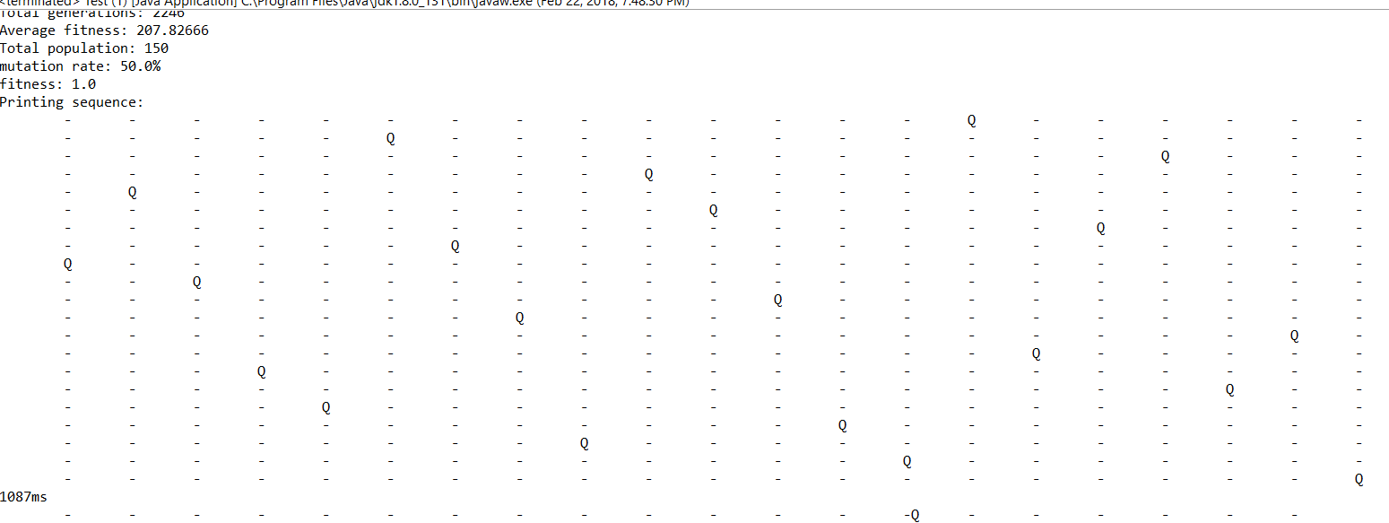

Random Hill Climb

